**Home Page-**

When you click on the Request handyman button on the top of the home page it takes you to the login screen, but there is nothing there to indicate where you can sign up or register as a user. There should be a “Sign up/Login” text view for the users to see. That way they know where to sign up.

The “Welcome to Mender” font and subtitle font need to be changed to Quicksand.

The pictures behind the “Welcome to Mender” text aren’t changing? They should be changing as well as the text, just like the old website. This is to show customers what we offer, how we operate, and other information that can be found on the old website. If you look at the old website, you will see why the pictures should be changing, as they all offer different selling points to customers.

I’d like the pictures below to be circled like the old website as well. Having them just as rectangles looks a bit sloppy. The text next to the images should be condensed and “taller.” (see old website for example.)  
  
Remove the “Our latest Projects” Section as I don’t have time to change that. Maybe temporarily remove it so I can implement it at a later time when I have more time?

While the buttons are correct on the bottom of the home screen, I’d like to change them to just two buttons. “Contact us” and “Request a handyman.”

In the footer, there is a textview that says, “Add Widget Column 1.” Please remove.

**Log in-**

Where do you sign up? There is nothing to indicate where you can sign up or register as a user. There should be a “Sign up/Login” text view for the users to see. That way they know where to sign up.

**Job Listings page-**

Table looks very nice. It doesn’t hold all the information in it though. I just see Names, Date Posted, Email Address, Job Title, Job Description sections. Where is Job Address, Job Address-2, Job Name, Job Phone Number, Job City, Job Zipcode, Images?

Also I didn’t see anything that indicates that there are multiple pages of jobs such as a 1,2,3,4,5 “Next” “Back” etc.

Of all the pages on this website, this is the most important page, because this is where the users will be spending most of their time. If they need to find a certain job, I want it to be as easy as possible for them.

The search bar is missing as well, I liked that feature, I was hoping to keep that. Can we put that back in there?

Job title and Job Description are empty?

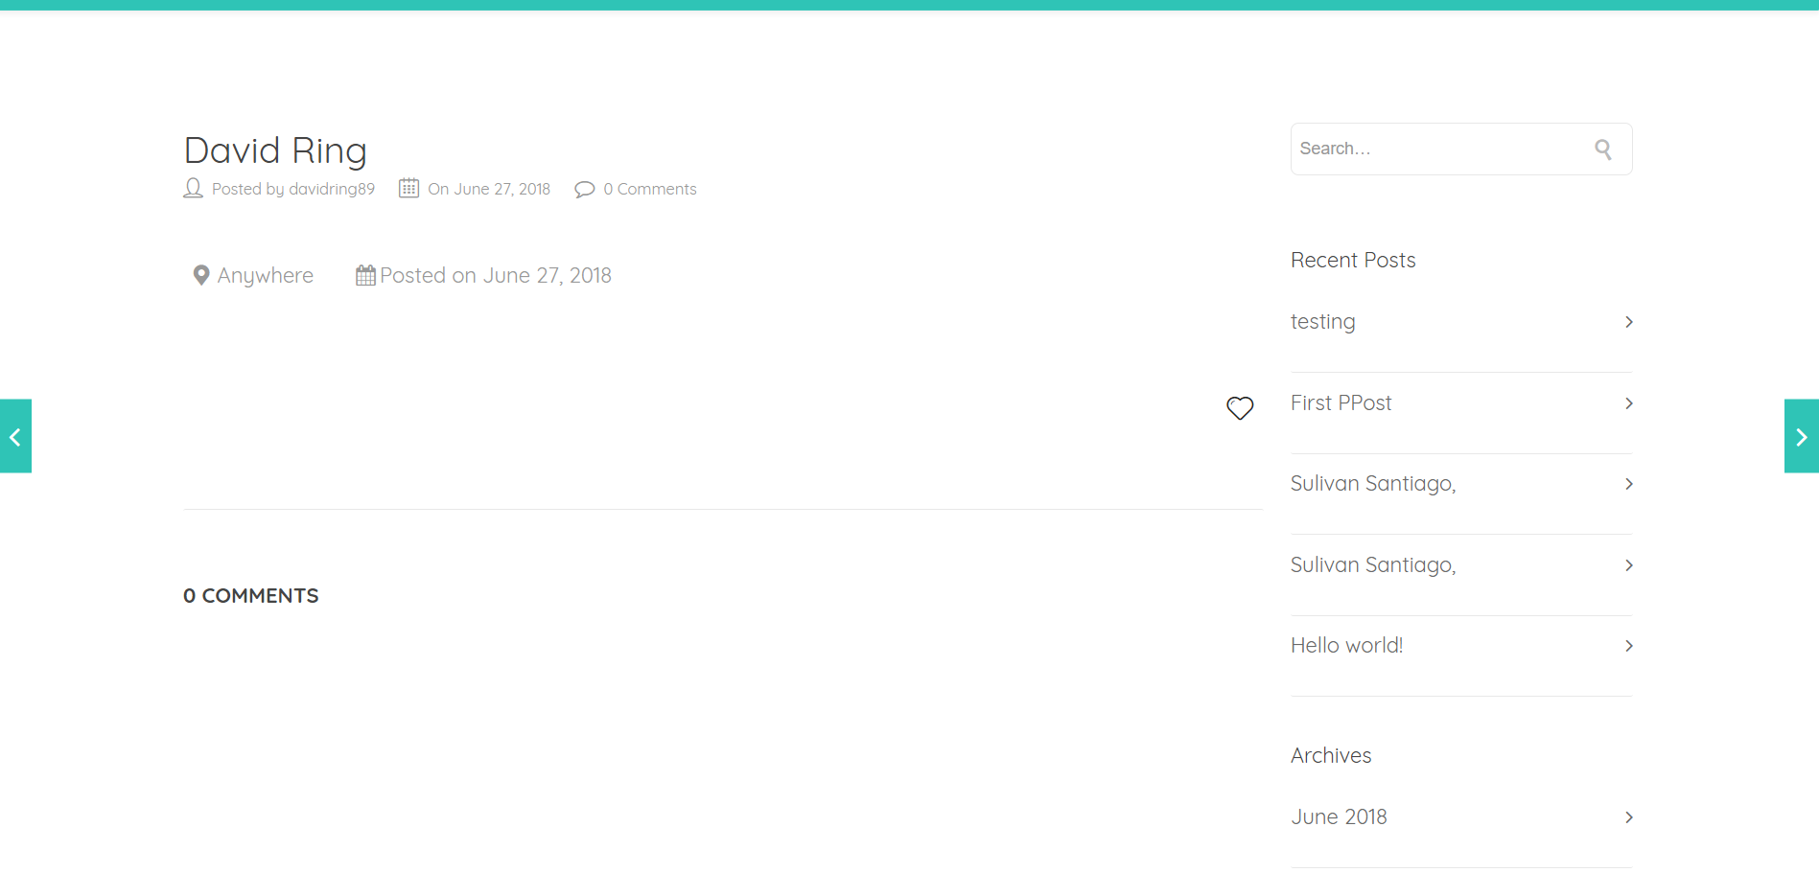

^^What is this? This is the screen you are redirected to when you edit a job, but it doesn’t have any relevant information to what you just edited. I would like to hide this screen from users. When you edit a job, you should be redirected to the Job List page. Not this one.

I just edited a job and the Values in the table are in the wrong sections.

**Job Post tab-**

Replace with Job Request Form-

**Header Menu Items-**

Services tab and Rates tab should be removed and put into the About us section as tabs.

**Job Request form-**

So I am a little confused here. As far as I can tell, there are two different job request forms, one is on the outside of the login section, the other, available when you log in. I don’t see why this was done. Let put the Job Request Form inside the login section, to replace the Job Post. I prefer the layout of the Job Request Form to the layout of the Job Post.

Even after your edits the job request form still was not working when I attempted to use it. I kept getting errors.

Now that we have user login capabilities, we do not need the Your name, Your Phone Number. Your Email Address fields on the Job Request forms. That information should automatically be put in Firebase from the users account information.

Put the Job City field to the right of Job Address-2 field and extend Job Title field to full width of the form like Job Address field.

Some of the Font on the Job Request Form still needs to be changed to Quicksand.

Are users able to upload more than one picture? This is very important; they need to be able to upload more than one photo.

The time and date fields should be optional, not required to submit Job Request.

**Log out-**

Instead of redirecting to an empty page that says “You are attempting to log out of handyman, do you really want to log out?” Can we turn that into a dialog?   
  
I’d also like that dialog to have a “Yes” “No” option instead of just a clickable “logout” textview.

**Services tab-**

Overall the services tab looks pretty good. There is a lot of things going on here though. The page looks very “busy.”

Let’s remove the grey bar with the white text in it under the Services Title.

Can we put pictures on both sides of the list of available services?

“Are you ready to be part of our 2000+ satisfied clients?” Remove for now.

Remove the random photos on the bottom of the page.

**Rates tab-**

Rates tab is nice, but unorganized.

Let’s remove the “What about our new product” text and image and start the page off with “Mender charges $75 per hour for labor time with a 1-hour minimum.” Section. I’d really like this section to look just like the old one on the old site. Starting with Labor time costs, then Drive time costs, Then Material costs.

Remove the “Don’t hesitate to” text and the Button under it.

Remove the “Request a handyman” button.

**About us tab-**

Needs to be rebuilt and organized. List of Services tabs has nothing in it, Terms and Conditions, Terms of Use, and Privacy Policy need to be updated. Also need to add Rates and Services tabs in here. Please organize this page.

Remove “Frequently Asked Questions” text under title.